Products Class UML

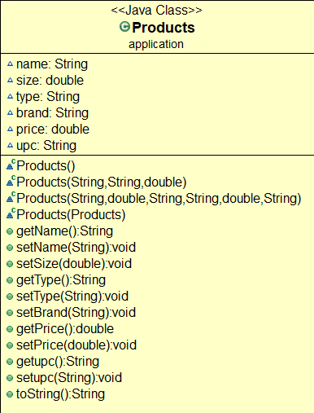

Name of the product

Size of the Product

Type of product

Brand of product

Price for (1)(default 0.00)

UPC is product barcode number

Creates the name of the product

Returns the name

Creates the size

Returns the size

Creates the Type

Returns the type

Creates the Brand

Returns the brand

Creates the price

Returns the price

Creates the UPC

Returns the UPC

String all variables

Dispenser Class UML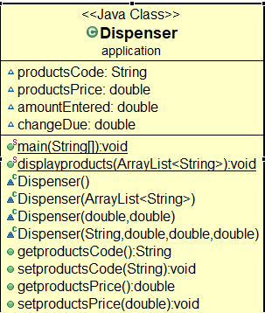

String the UPC

Show price

Show amount

If payed/ show change to be returned

Creates ArrayList of all products

Creates Dispenser

Creates ArrayList in Dispenser

Returns UPC

Creates Price for selected product

Returns Price